**Experiment No. 02**

**Aim: To study and implement input – output statements and control and loop statements.**

**Code and Output:**

**To find square root**

import math

x=int(input("Enter the number whose sqrt has to be found:"))

print(math.sqrt(x))

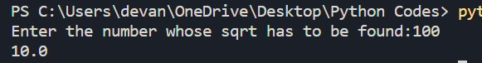

**To find length and breadth of rectangle:**

x=int(input("Enter the length of the rectangle: "))

y=int(input("Enter the length of the rectangle: "))

perimeter=2*(x+y)

area=x*y

print(f"The perimeter is:{perimeter}")

print(f"The area is:{area}")

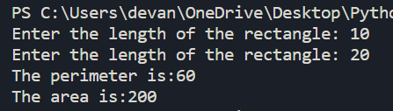

**To swap 2 numbers:**

a=int(input("Enter the first number:"))

b=int(input("Enter the second number:"))

temp=a

a=b

b=temp

print(f"The new a after swap is:{a}")

print(f"The new b after swap is:{b}")

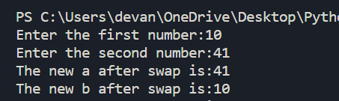

**Adding elements in List, Tuple, Set**

x=["apple","oneplus","lenovo","hp","samsung"]

z=["mi","pastonji"]

y=("apple","oneplus","lenovo","hp","samsung")

x.append("dell")

print(x)

x=x+z

print(x)

x.pop()

print(x)

x.insert(2,"sony")

print(x)

z=("DELL",)

a=y+z

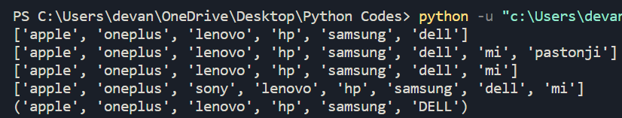print(a)

**Factorial**

a=int(input("Enter the number whose factorial has to be found: "))

i=1

fact=1

while a!=0:

fact=fact*a

a=a-1

print(f"The factorial is:{fact}")

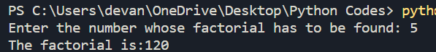

**Fibonacci**

n=int(input("Enter the number of elements in the Fibonacci Series:"))

a=0

b=1

c=0

print("The series is:")

print(f"{a}")

print(f"{b}")

for i in range(n-2):

c=a+b

print(f"{c}")

a=b

b=c

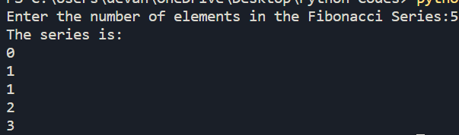

**Leap year**

n=int(input("Enter the year to check if it is leap or no:"))

if n%400==0:

print(f"{n} is a leap year")

elif n%100==0:

print(f"{n} is not a leap year")

elif n%4==0:

print(f"{n} is a leap year")

else:

print(f"{n} is not a leap year")

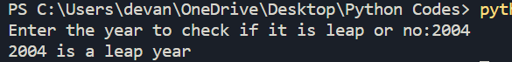

**Continue, break, pass**

n=int(input("Enter a number"))

for i in range(n):

if i==0:

print("This is demonstration for pass statement")

pass

elif i==4:

print("This is a demo for the continue statement")

continue

elif i==10:

print("This was a long journey. Breaking the loop")

break

else:

print(i)

